**Hale School**

**Year**

**11**

**Semester**

**2**

**Examination, 2020**

**ADAPTED TO NEW COURSE**



**ECONOMICS**

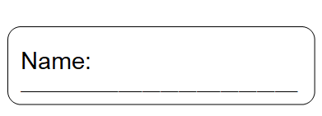

**TIME ALLOWED FOR THIS PAPER**

Reading time before commencing: Ten minutes

Working time for paper: Three hours

**MATERIAL REQUIRED/RECOMMENDED FOR THIS PAPER**

TO BE PROVIDED BY THE SUPERVISOR

This Question/Answer booklet for Section One and Two

Separate Multiple Choice Answer sheet for Section One.

Standard 8 Page Answer booklets (green) for Section Three.

**TO BE PROVIDED BY THE CANDIDATE**

Standard items: Pens, pencils, eraser or correction fluid, ruler

Special items: A blue/black pen or 2B pencil for the separate Multiple Choice Answer Sheet and a non-programmable calculator approved for use in this examination.

**IMPORTANT NOTE TO CANDIDATES**

No other items may be taken into the examination room.

It is your responsibility to ensure that you do not have any unauthorised notes or other items of a non-personal nature in the examination room. Please check carefully, and if you have any unauthorised material with you, hand it to the supervisor **BEFORE** reading any further.

**INSTRUCTIONS TO CANDIDATES**

Answer **ALL** questions - Note that there is a choice of extended answer (essay) topics. This paper consists of **THREE PARTS** as follows:

|  |  |  |  |  |  |
| --- | --- | --- | --- | --- | --- |
| **Section** | **Format** | **No. of questions available** | **No. of questions to be attempted** | **Suggested time/minutes** | **Marks** |
| One | Multiple Choice | 24 | 24 | 30 | 24 |
| Two | Data Interpretation / Short Answer | 3 | ALL | 70 | 36 |
| Three | Extended Writing | 4 | 2 | 80 | 40 |
|  |  |  |  | **Total marks** | **100** |

1. The rules for the conduct of WACE Examinations are detailed in the booklet *WACE Handbook*. Sitting this examination implies that you agree to abide by these rules.
2. You must be careful to confine your answers to the specific questions asked and to follow any instructions that are specific to a particular question.
3. Supplementary pages for the use of planning/continuing your answer to a question have been provided at the end of this Question/Answer booklet. If you use these pages to continue and answer, indicate at the original answer where the answer is continued i.e. give the page number.

At the end of the examination make sure that your **Name** is on your Examination paper, the separate Answer Booklets and your Multiple Choice Answer Sheet.

**Section One: Multiple Choice 24% (24 Marks)**

This section has **24** questions. Answer **all** questions on the separate Multiple-choice answer

sheet provided.

**Suggested working time: 30 minutes**

_________________________________________________________________________

1. If planned leakages exceed planned investment over a given period:
2. Output will rise
3. Cyclical unemployment will rise
4. The rate of inflation will rise
5. Incomes will rise
6. Using data in the table below identify the country that will experience a fall in income, output and expenditure in the future.

|  |  |  |  |  |  |
| --- | --- | --- | --- | --- | --- |
| Country | Income ($b) | Consumption ($b) | Planned investment ($b) | Government spending ($b) | Net exports ($b) |
|  | 100 | 60 | 20 | 25 | -5 |
|  | 100 | 75 | 10 | 15 | 5 |
|  | 100 | 60 | 15 | 15 | 0 |
|  | 100 | 55 | 20 | 25 | 0 |

1. Which of the following pairs of events would indicate that an economy is starting to recover from a trough?
2. Rising interest rates and lower numbers of job advertisements
3. Mining investment is low and hotel booking rates are low
4. Inflationary pressure and excess capacity in manufacturing industry
5. Falling levels of inventory and rising retail sales
6. Which of the following would be considered leading economic indicators?

i. Share prices

ii. Inflation rate

iii. Unemployment rate

iv. Building approvals

v. Real GDP

1. ii and iii
2. i and iv.
3. ii and v
4. iv and v

See next page

1. Real GDP rose from $250 Bn in Year 1 to $255 Bn in Year 2. Over the course of the year, population rose 2.1%. On these figures, we would conclude that
2. real GDP per capita fell
3. real GDP per capita rose
4. there was no change in welfare
5. the economy had gone into a recession

Question 6 refers to the model below

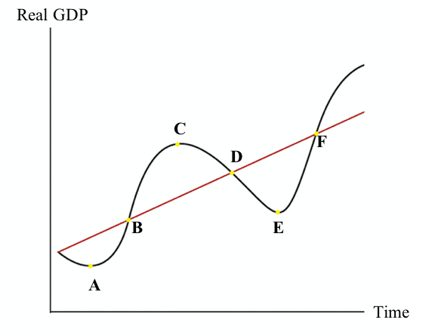

1. In a business cycle, if an economy is experiencing low inflation, rising cyclical unemployment and low levels of import spending then it is likely to be moving from:
2. A to B
3. C to D
4. B to C
5. D to E
6. The term 'capital deepening' refers to
7. public investment on infrastructure such as railways and ports.
8. a 5% increase in the nations capital stock which accompanies a 5% increase in other factors used in production.
9. an increase in the stock of capital relative to the stock of labour inputs.
10. investment in long term projects which are likely to show a positive return only after several years.
11. Which of the following is **not** likely to cause inflation?
12. An increase in income tax
13. Rising import prices.
14. An increase in government spending.
15. Increases in wage rates matched by an increase in labour productivity.

See next page

|  |  |
| --- | --- |
| Period | CPI |
| June 2019 | 114.8 |
| Sept 2019 | 115.4 |
| Dec 2019 | 116.2 |
| March 2020 | 116.6 |
| June 2020 | 117.0 |

1. Refer to the data in the table right, which shows quarterly Consumer Price Index (CPI) numbers for Country X. As at June 2020, the annual rate of inflation stood at ________; and the quarterly rate was _________.
2. 2.2%; 0.3%
3. 1.4%; 0.3%
4. 1.9%; 0.3%
5. 1.2%; 1.1%
6. Which of the following is a **correct** statement based on the data in the table.

|  |  |
| --- | --- |
| Total population | 25m |
| Population of working age | 20m |
| People employed | 14m |
| People unemployed | 1m |

1. The participation rate is 75% and the unemployment rate is 7.14%
2. The participation rate is 70% and the unemployment rate is 7.14%
3. The participation rate is 80% and the unemployment rate is 6.67%
4. The participation rate is 75% and the unemployment rate is 6.67%
5. One weakness (or limitation) of the CPI is that it does **not**
6. reflect the average Australian’s purchases of goods and services
7. account for changes in the quality of goods over time
8. account for changes in price levels of consumer goods
9. reflect a change in the base year for inflation calculations
10. Which of the following statements about Real Gross Domestic Product (GDP) is **false**?
11. It includes the value of home-based duties
12. It adjusts the value of production for inflation
13. It can be used to indicate changes in material living standards
14. It gives little indication of how evenly the benefits of production have been distributed
15. The table shows hypothetical data for an economy

|  |  |  |  |  |  |
| --- | --- | --- | --- | --- | --- |
| S | G | M | T | I | X |
| 200 | 400 | 350 | 300 | 350 | 250 |

Which row of the table is correct for the economy?

|  |  |  |
| --- | --- | --- |
|  | Trade balance | Economic Growth |
|  | Surplus | Positive |
|  | Surplus | Negative |
|  | Deficit | Positive |
|  | Deficit | Negative |

1. Which of the following is not an economic objective of the Australian Government?
2. Price Stability
3. A more equitable distribution of income and wealth
4. External trade
5. Full employment
6. Where the tax is collected is the ________ of the tax and where the burden of the tax falls is the _________ of the tax.
7. Size, incidence
8. Impact, size
9. Impact, incidence
10. Incidence, impact
11. What is the definition of an efficient tax?
12. A tax that is cheap to collect
13. A simple flat rate tax
14. The benefits of collecting the tax should outweigh the costs of collecting the tax
15. A tax that raises enough money to sustain government spending
16. The difference between disposable income and final income is
17. direct tax
18. direct benefits
19. indirect benefits
20. interest, rent and dividends
21. The Gini Co-efficient can be defined as
22. a measurement of income inequality in a country
23. a measure to describe perfect income equality
24. a measure that explains how income is evenly distributed
25. none of the above
26. If Country A has a Gini coefficient of 0.54 and Country B has a Gini Coefficient of 0.32, then:
27. Country A has a more equal distribution of income than Country B
28. Country B has a more equal distribution of income than Country A
29. Country A has perfectly equal income distribution than Country B
30. Country B has a more inequitable distribution of income than Country

See next page

**Section Two: Data interpretation/Short response 36% (36 Marks)**

This section contains **three (3)** questions. Answer **all** questions. Write your answers in the

spaces provided. Supplementary pages for planning/continuing your answers to questions are provided at the end of this Question/Answer booklet. If you use these pages to continue an answer, indicate at the original answer where the answer is continued, i.e. give the page number.

**Suggested working time: 70 minutes.**

_________________________________________________________________________

**Question 20 (12 marks)**

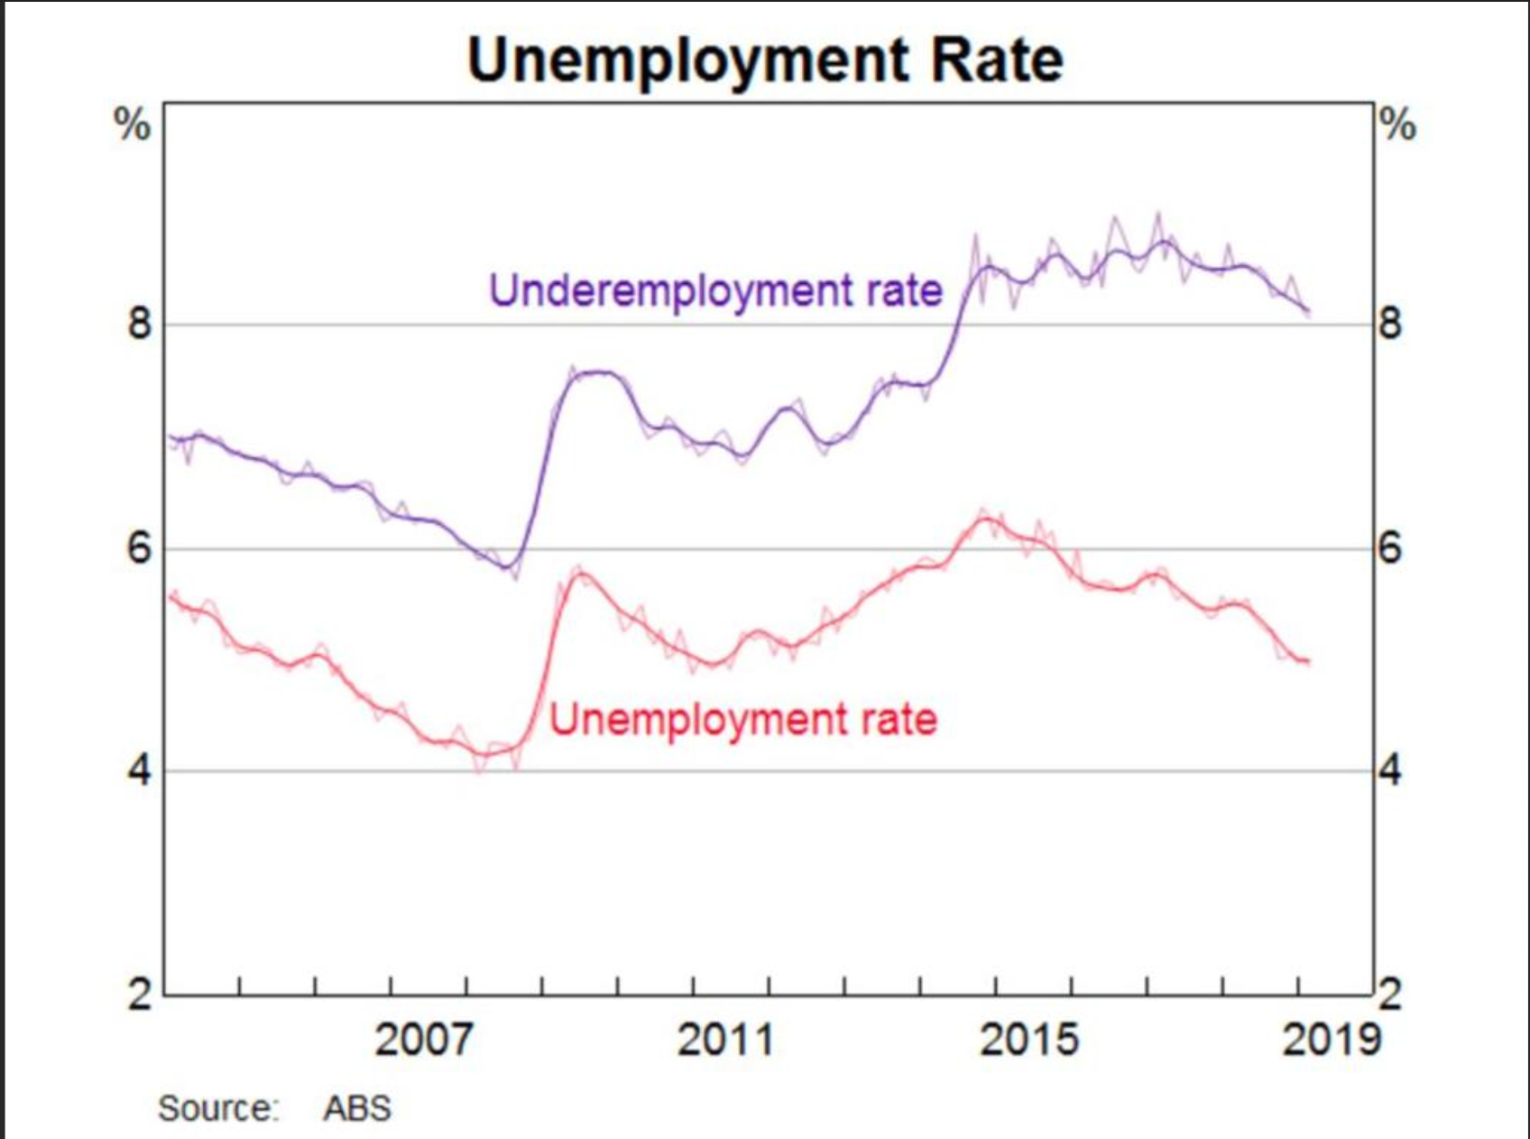

1. Calculate the underutilisation rate for 2019? ­­­­­­­­­­­­­­­­­______________ (1 mark)
2. "In 2020 the underemployment rate rose to 11.8%."

Define underemployment and explain why the underemployment rate rose in 2020.

(2 marks) ____________________________________________________________________________________________________________________________________________________________________________________________________________________________________________________________________________________________________

See next page

1. State the Natural Rate of Unemployment for Australia and outline the **two** types of unemployment that make up the Natural Rate of Unemployment. (3 marks)

_____________________________________________________________________________________________________________________________________________________________________________________________________________________________________________________________________________________________________________________________________________________________________________

_________________________________________________________________________

1. Describe **three** economic effects of unemployment. (6 marks)

Effect one

____________________________________________________________________________________________________________________________________________________________________________________________________________________________________________________________________________________________________

______________________________________________________________________

Effect two

_____________________________________________________________________________________________________________________________________________________________________________________________________________________________________________________________________________________________________________________________________________________________________________

Effect three ____________________________________________________________________________________________________________________________________________________________________________________________________________________________________________________________________________________________________

_________________________________________________________________________

See next page

**Question 21 (12 marks)**

The following table shows a number of key indicators of Australian economic performance over recent years.

|  |  |  |  |
| --- | --- | --- | --- |
| Year ended June | Economic growth | Inflation rate | Unemployment rate |
|  | *% per annum* | *% per annum* | *% of labour force* |
| 2016-17 | 2.4 | 1.9 | 5.6 |
| 2017-18 | 2.9 | 2.1 | 5.3 |
| 2018-19 | 2.0 | 1.6 | 5.3 |
| 2019-20 | -6.3 | -0.3 | 6.8 |

1. From the table, determine the Economic Growth rate and the Unemployment rate in 2019-20. (1 mark)

(i) Economic Growth rate = _________

(ii) Unemployment rate = ________

1. Using the data, outline the extent to which Australia has achieved its economic objectives over the period 2017-18 to 2019-20. (3 marks)

____________________________________________________________________________________________________________________________________________________________________________________________________________________________________________________________________________________________________________________________________________________________________________

____________________________________________________________________________________________________________________________________________________________________________________________________________________________________________________________________________________________________

__________________________________________________________________________________________________________________________________________________

See next page

1. The efficient allocation of resources is a government objective. State how this can be measured, and outline why is it an important objective to achieve? (2 marks)

____________________________________________________________________________________________________________________________________________________________________________________________________________________________________________________________________________

1. "Overall household consumption is estimated to have declined by around 10 per cent in the June quarter 2020."

Explain **three** factors that may have contributed to the decline in household consumption in the June quarter 2020. (6 marks)

Factor one

_______________________________________________________________________________________________________________________________________________________________________________________________________________________________________________________________________________________________________________________________________________

Factor two

_______________________________________________________________________________________________________________________________________________________________________________________________________________________________________________________________________________________________________________________________________________

Factor three

_________________________________________________________________________________________________________________________________________________________________________________________________________

______________________________________________________________________________________________________________________________________See next page

**Section Three: Extended answer40% (40 Marks)**

This section contains **four (4)** questions. Answer **two (2)** questions. Write your answers in the green booklets provided. One question to be answered per booklet.

**Suggested working time: 80 minutes.**

_________________________________________________________________________

**Question 22 (20 marks)**

1. Define the term modified market economy and using examples, explain the four key roles of the government in a modified market economy. (10 marks)
2. Define taxation and using examples and diagram(s), distinguish between proportional, regressive and progressive types of taxation. (10 marks)

_________________________________________________________________________

**Question 23 (20 marks)**

1. Using the **five-sector** circular flow of income model, explain how the economy might achieve a higher level of equilibrium if injections are greater than leakages.

(6 marks)

1. Describe **four** factors influencing investment in the Australian economy. (8 marks)
2. Discuss **three** determinants of economic growth. (6 marks)

_________________________________________________________________________

**Question 24**

1. Explain the difference between the headline and underlying measures of inflation.

(4 marks)

1. Describe the concepts of demand pull and cost push inflation, and outline how each would be affected in the boom phase of the business cycle. (10 marks)

1. Explain how high inflation may impact the following groups: (6 marks)
2. Fixed income earners.
3. Borrowers.
4. Australian exporters.

**End of exam**

***Supplementary pages***

_____________________________________________________________________________________________________________________________________________________________________________________________________________________________________________________________________________________________________________________________________________________________________________________________________________________________________________________________________________________________________________________________________________________________________________________________________________________________________________________________________________________________________________________________________________________________________________________________________________________________________________________________________________________________________________________________________________________________________________________

_________________________________________________________________________________________________________________________________________________________________________________________________________________________________________________________________________________________________________________________________________________________________________________________________________________________________________________________________________________________________________________________________________________________________________________________________________________________________________________________________________________________________________________________________________________________________________________________________________________________________________________________________________________________________________________________________________________________________________________________________________________________________________________________________________________________________________________________________________________________________________________________________________________________________________________________________________________________________________________________________________________________________________________________________________________________________________________________________________________________________________________________________________________________________________________________________________________________________________________________________________________________________________________________________________________________________________________________________________________________________________________________________________________________________________________________________________________________________________________________________________________________________________________________________________________________________________________________________________________________________________________________________________________________________________________________________________________________________________________________________________________________________________________________________________________________________________________________________________________________________________________________________________________________________________________________________________________________________________________________________________________________________________________________________________________________________________________________________________________________________________________________________________________________________________________________________________________________________________________________________________________________________________________________________________________________________________________